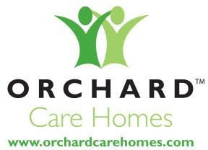

Modern Slavery Act 2015

Modern slavery and human trafficking statement

Modern slavery is a crime and a violation of fundamental human rights. It takes various forms, such as slavery, servitude, forced and compulsory labour and human trafficking, all of which have in common the deprivation of a person's liberty by another in order to exploit them for personal or commercial gain.
Orchard Care Homes is committed to improving our practices to combat slavery and human trafficking.

This statement is made pursuant to section 54(1) of the Modern Slavery Act 2015 and constitutes Orchard Care Homes’ slavery and human trafficking statement for the financial year ending 2021.

Orchard Care Homes
Orchard Care Homes has been running and managing care homes across the UK for over a decade. With a strong reputation in the care industry, we provide quality care primarily for the elderly, and in some homes, for those with additional needs. Orchard strives to be at the heart of the local community and is working in partnership with national organisations, including charities to deliver the best care possible.

Our supply chains.
Our supply chains relate to the provision of maintenance services, the procurement of food and beverages, the engagement of temporary and agency staff, and covering utilities and waste management. Our anti- slavery policy forms part of our agreement with suppliers. We expect high standards of all our suppliers and that they work to all relevant requirements under the Modern Slavery and Human Trafficking Act.

OUR POLICIES ON SLAVERY AND HUMAN TRAFFICKING

We are committed in ensuring that there is no modern slavery or human trafficking in our supply chains or in any part of our business. Our policy includes guidance on indicators of forced labour and where additional information and support can be found. Where the company identifies any indications of forced labour this would be addressed via the internal serious untoward incident process and reported as required.
Considering the obligation to report on measures to ensure that all parts of our business and supply chain are slavery free we continually review our workplace policies and procedures to assess their effectiveness in identifying and tackling modern slavery issues.
Our workplace policies and procedures demonstrate our commitment to acting ethically and with integrity in all our business relationships and to implementing and enforcing effective systems and controls to ensure slavery and human trafficking is not taking place anywhere in our supply chains.

1

Due diligence processes for slavery and human trafficking

As part of our initiative to identify and mitigate risk we:
We have implemented a risk assessment to identify potential areas of required improvement, this is monitored regularly to maintain compliance.
- We will work closely with our suppliers to ensure that they have taken all reasonable measures to comply with the Modern Slavery and Human Trafficking Act

- We are committed to confronting this crime through effective due diligence and risk assessment, raising awareness of modern slavery and collaborating to protect the most vulnerable groups of people.

- Operate and promote a Whistleblowing policy, providing an open, transparent and confidential opportunity for employees to raise any concerns where slavery or human trafficking might be suspected.

- Provide an additional open communication with Company Chief Executive Officer, Hayden Knight supported by the Senior Leadership and HR Teams.

We have in place systems to:
  - Identify and assess potential risk areas in our supply chains.
  - Mitigate the risk of slavery and human trafficking occurring in our supply chains.
  - Monitor potential risk areas in our supply chains.
  - Protect whistle blowers.
  - Investigate any reports of modern slavery practices. Should any such practices be proven, Orchard Care Homes will terminate applicable contracts accordingly.

Supplier adherence to our values

We have zero tolerance to slavery and human trafficking. To ensure all those in our supply chain including contractors comply with our values we have in place a supply chain compliance programme.
- The percentage of suppliers who sign up to an appropriate code / provide their own modern slavery statements.

- We will remove any suppler or organisation from our supplier list should any reports of modern slavery be notified.

- Our Recruitment Policy includes verification of Right to Work Eligibility, DBS checks and UKBA (UK Border Agency) compliance ensuring that we safeguard against human trafficking and forced labour.
2

Training

To ensure a high level of understanding of the risks of modern slavery and human trafficking in our supply chains and our business, we provide awareness training to our staff via Induction.

Our Performance Indicators Include

Staff are trained in the awareness of the Modern Slavery Act

The company receives no reports of practices which contravene the Modern Slavery Act

Regularly review the statement to ensure that Orchard Care Homes is compliant and meeting the requirements of the Modern Slavery Act 2015

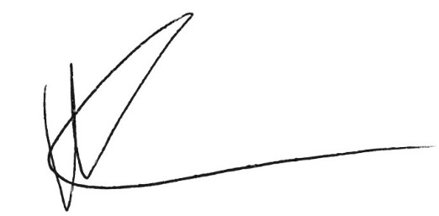

Hayden Knight
Chef Executive Officer
3

